Lab 4

Lab 4 – Introduction to Linux Systems Part 2

By

Lukas Fuller

IAE-201-D02

Intro to Linux Training

**Abstract**

The objective of this lab is to introduce students to the Linux operating system and more specifically the Kali Linux operating system. The student will be able to understand BASH variables, system processes, and several advanced utility commands. The student will understand basic Linux networking setup.

**Materials**

1. Kali Linux VM

**Conclusion**

So far in Kali, the majority of the commands seem to be in most cases smaller than the action that they are doing, which makes understanding what certain characters do much easier. In a couple cases like “ping”, “unset”, or “find”, they all are self-explanatory as to what their functions are and are not shorter then there functions. Also, downloading files is quite simple if you know the file’s path on a website. Overall, I feel like I’m slowly getting more knowledge as to how the Kali Linux environment works.

**Screenshots**

1. Set your name to a variable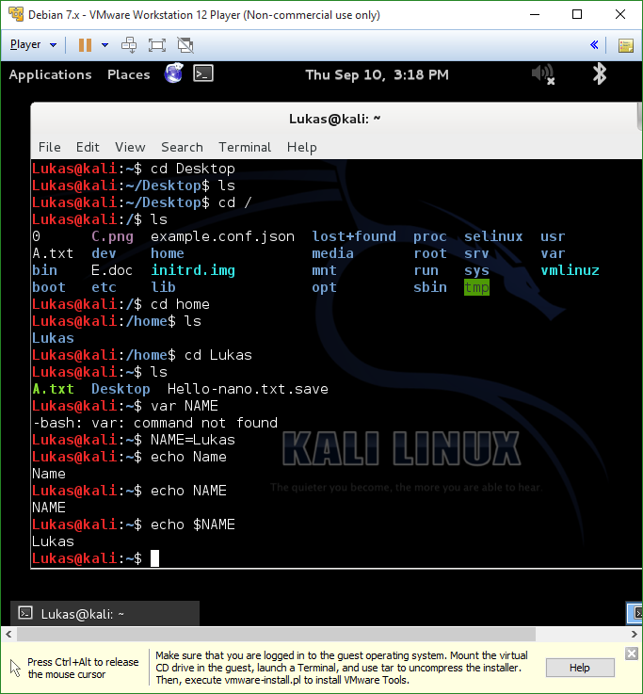

2. Printing out all environment variables with “env” 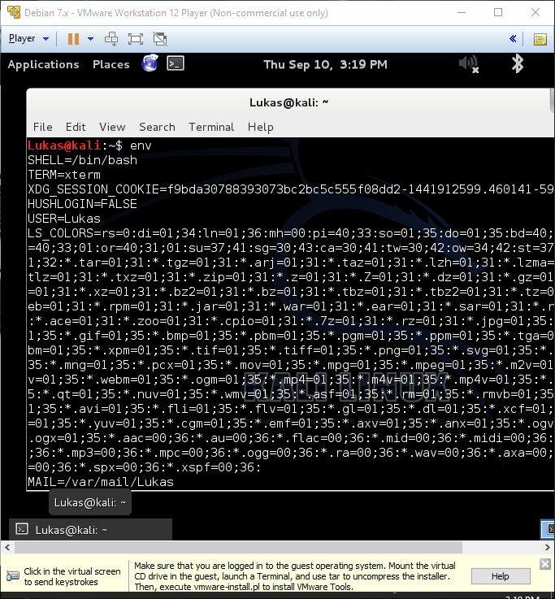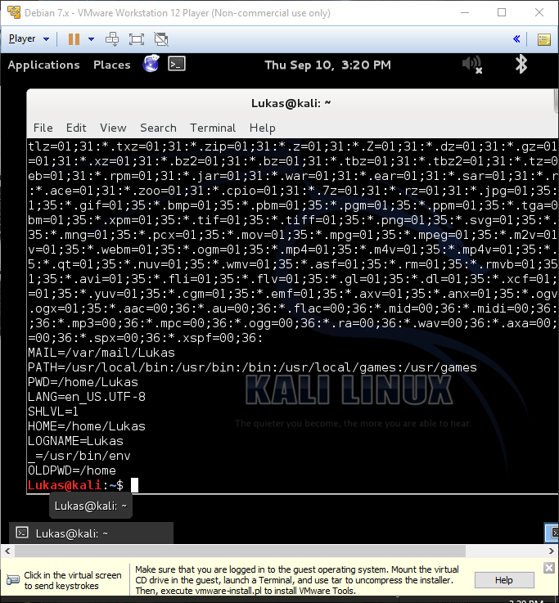

3. Comparing “Hello-World.txt” and “Hello-UNIX.txt” with “cmp”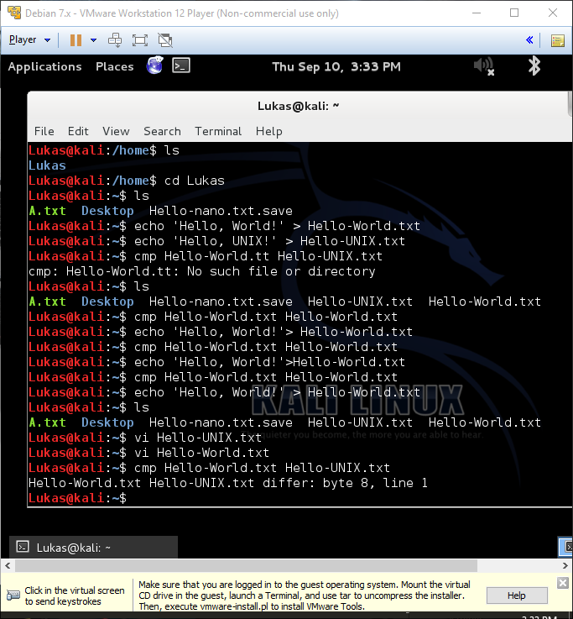

4. Pinging Google.com

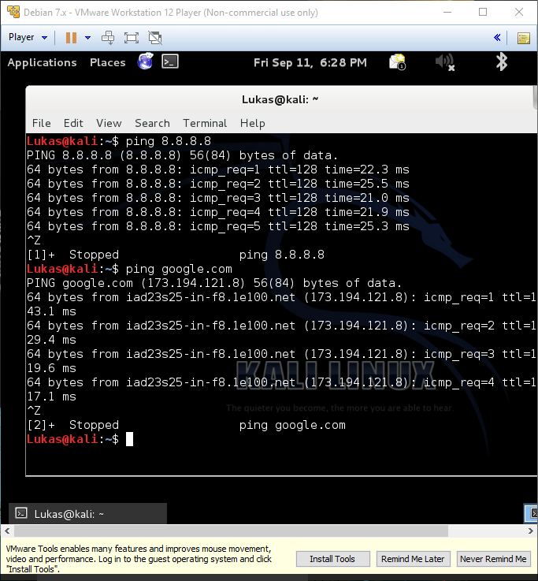

5. Hello-wget.txt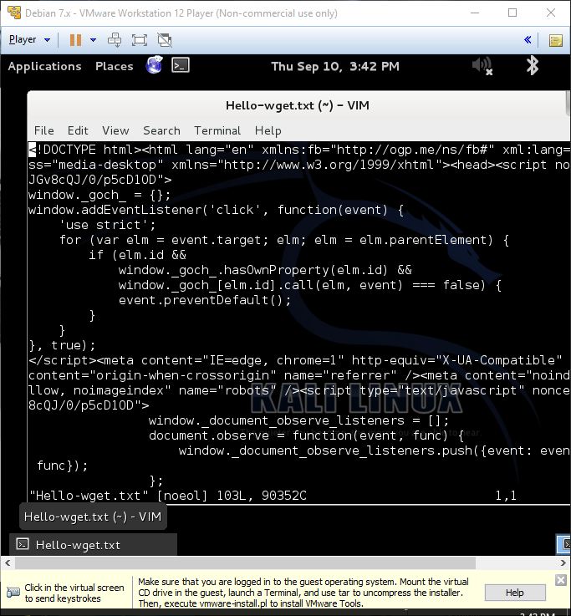

6. Compressing a folder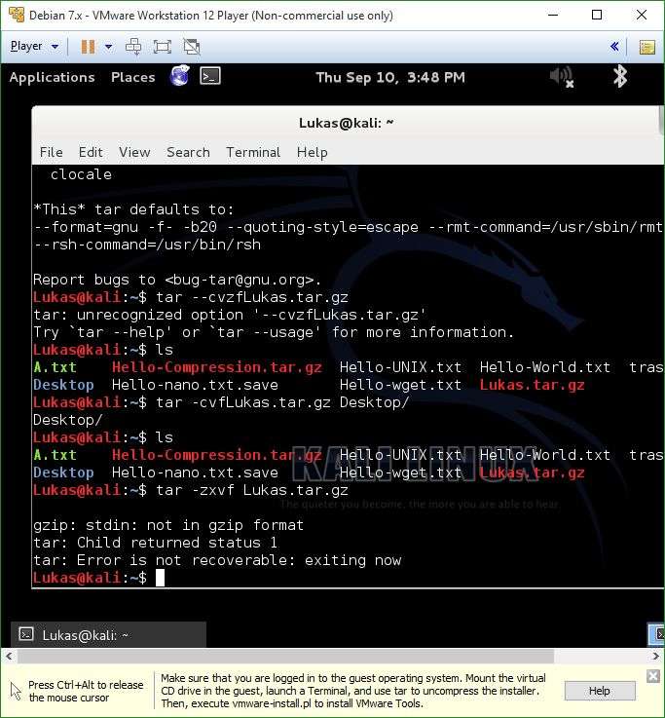

**Questions**

1. How would you set a BASH variable that stores your age? **AGE=18**
2. How do you think you would append to the already existing BASH variable PATH with the value “:/bin”? **BASH=:/bin**
3. How would you find all the files on your system that have the word “conf” in its filename? **grep *conf**
4. How would you find out what the PID of a running process is? **pse –e | grep yes**
5. How would you stop the process running with PID 3085? **kill 3085 <PID>**
6. How would you ping amazon.com? **ping amazon.com**
7. What command do you use to download a file from the internet without a web browser? **wget**
8. How would you unzip an archive called “09172013.tar.gz”? **tar –zxvf 09172013.tar.gz**